**What is Grafana?**

1. Grafana is open-source software and tool which is used for monitoring and analytics purpose.

2. Grafana can connect to most of the databases like Nosql, relational, time series, graph data,etc in same dashboard

3. Using Grafana we can set alerts, visualize data and understand metrics for making better decisions.

4. Since it is data driven, we can create dashboards and share them across.

More about Grafana?

They usually release latest version every two weeks and for any questions and queries you can visit

[Grafana Labs Community Forums](https://community.grafana.com/)

Grafana is available on Ubuntu, other RPM based Linux, macOS and Windows

For windows, you can download Grafana from below link

[Download Grafana | Grafana Labs](https://grafana.com/grafana/download?platform=windows)

Download the zip version as antivirus in your machine can block the installation   
grafana-enterprise-<version>.windows-amd64.zip

Once you download the zip, extract it and run Grafana-server.exe

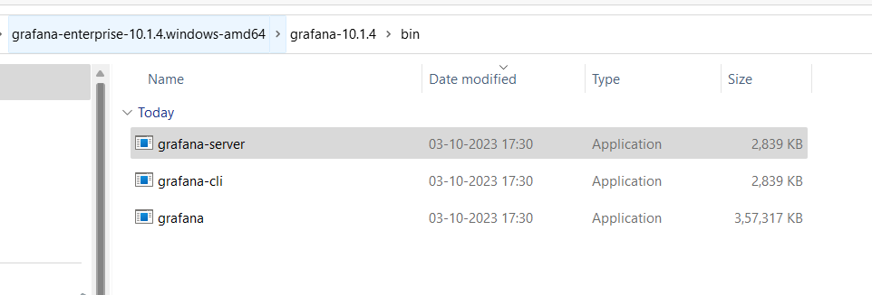

It will start the Grafana services. By default the port is 3000.

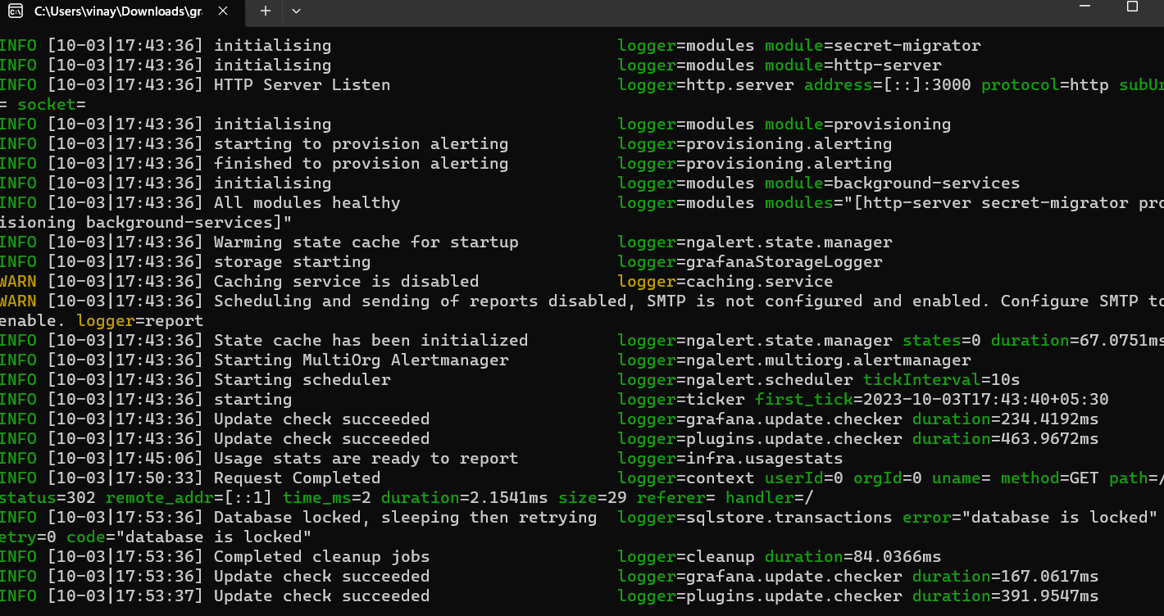

**Login into Grafana UI**

<http://localhost:3000/>

